DEPARTMENT OF CHEMISTRY
UNIVERSITY COLLEGE FOR WOMEN (Autonomous), Koti, Hyderabad

Report on Three Industrial Trips conducted by Department of Chemistry for PG final year students in the academic year 2021-22.

- Industrial visit to Symed Labs on 8th March 2022

M.Sc. Analytical Chemistry Semester III pursuing students visited Symed labs Unit -II, Jedimetla on receiving permission letter from them, as part of their Industrial visit on 8-3-22 along with two faculty members. Mr.T.K Prasad, Senior Plant manager and Mr.M.Ravinder Reddy, Plant Head received our members at the entrance at 11.00 am and gave an introduction about the industry. Later our members were given helmets, lab coats and masks and senior analysts of the industry were assigned to explain the various divisions of the industry starting from administration division, ware house , utility center, production unit, QC unit I & II and QA unit.
Our analytical chemistry students learnt sampling procedures commonly used for wet analysis adopted for sample testing and various instrumentental techniques on visiting QC division. A clear insight about various instruments to name few Potentiometer, Coulometer, UV-VIS spectrometer, FT-IR, TGA, XRD, GC, HPLC and ICP-MS were explored. This session was quite informative and interactive to the students. Further in QA division, concepts and significance of QA programme, filing the documentation, generating SOP’S, STP’S and various Good laboratory procedures adopted were detailed . Thus, at the end of the visit students acquired much knowledge about an industry and the journey was very informative, interesting and successful visit.
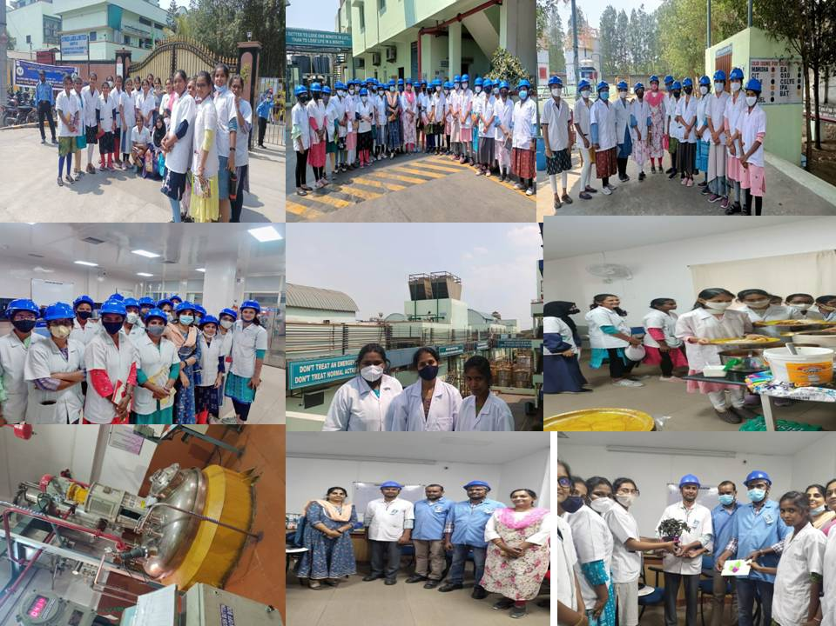
- Industrial visit to SS Organics Limited, Sangareddy on 17th March 2022
Place of visit: S S Organics Ltd
Date of visit: 17th March, 2022
A batch of 52 M.Sc III Semester students of Department of Chemistry (M.Sc Organic chemistry and Pharmaceutical Chemistry) along with HOD and 5 faculties visited S S Organics Ltd located at Sangareddy
Objective of Visit: Industrial visits help to bridge the gap between classroom and the real
World. Objective is to provide real life exposure about the
Technology and equipments used for different processes in an industry.

Visit: S S Organics was started as private limited company in the year 1990 and subsequently converted into Ltd Company in 1993 with the objective of carrying on the business of manufacturing Pharmaceutical intermediates.
The visit started with a presentation explaining the different processes and challenges faced in bulk production. Thereafter, after lunch firstly visited R & D Process development lab where students were made familiar with working of TLC, UV Chamber, Mantles, autoclave, Rota vapor, and stirrers. Later visited Quality control wet lab, where students were briefed by quality analysts about vaccum oven, hot air oven, KF Titrator and digital TDS Meter followed by instrumentation lab where working of GC and HPLC was explained. The main attraction of the visit was looking at Heavy duty reactors like SSR, SLR & GLR in production unit. Along with these Warehouse containing raw materials, utilities with chilling plant, Hot and cold well were shown. As a part students even visited Effluent treatment plant where detailed overview was given.

Outcome of Visit: The technology and equipments used were made familiar. The various processes involved in production was explained.

