DEPARTMENT OF GENETICS & BIOTECHNOLOGY

UNIVERSITY COLLEGE FOR WOMEN, KOTI, HYDERABAD.

BOARD OF STUDIES MEETING 2020-2021

Telangana State Council of Higher Education, Govt. of Telangana B.Sc.,
CBCS Common Core Syllabi for all Universities inTelangana
BScGENETICS(wef2020-2021)
FIRST YEAR- SEMESTER I
CODE | COURSE TITLE | COURSE  TYPE | HPW | CREDITS
BS 101 | Environmental Science/Basic Computer Skills | AECC-1 | 2 | 2
BS 102 | English | CC-1A | 4 | 4
BS 103 | Second language | CC-2A | 4 | 4
Bs 104 | Optional I- Transmission Genetics | DSC-1A | 4T+3P=7 | 4+1=5
BS 105 | Optional II | DSC-2A | --------- | 4+1=5
BS 106 | Optional III | DSC-3A | --------- | 4+1=5
 | TOTAL |  |  | 25
FIRST YEAR- SEMESTER II
BS 201 | Gender Sensitization | AECC-2 | 2 | 2
BS 202 | English | CC-1B | 4 | 4
BS 203 | Second language | CC-2B | 4 | 4
Bs 204 | Optional I- Molecular Genetics & Genetic Engineering | DSC-1B | 4T+3P=7 | 4+1=5
BS 205 | Optional II | DSC-2B | --------- | 4+1=5
BS 206 | Optional III | DSC-3B | --------- | 4+1=5
 | TOTAL |  |  | 25
SECOND YEAR –SEMESTER III
BS 301 | Genetic Analysis& Model organisms | SEC-I | 2 | 2
BS 302 | Cytogenetics-Lab Processing and Analysis | SEC-2 | 2 | 2
BS 303 | English | CC-1C | 3 | 3
Bs 304 | Second language | CC-2C | 3 | 3
BS 305 | Optional I- Biostatistics & Bioinformatics | DSC-1C | 4T+3P=7 | 4+1=5
BS 306 | Optional II | DSC-2C | --------- | 4+1=5
BS 307 | Optional III | DSC-3C | --------- | 4+1=5
 | TOTAL |  |  | 25
SECOND YEAR –SEMESTER IV
BS 401 | Biophysical and Molecular Biology techniques | SEC-3 | 2 | 2
BS 402 | DNA technology in health care &Transgenics | SEC-4 | 2 | 2
BS 403 | English | CC-1D | 3 | 3
Bs 404 | Second language | CC-2D | 3 | 3
BS 405 | Optional I- Industrial Biotechnology | DSC-1D | 4T+3P=7 | 4+1=5
BS 406 | Optional II | DSC-2D | --------- | 4+1=5
BS 407 | Optional III | DSC-3D | --------- | 4+1=5
 | TOTAL |  |  | 25

THIRD YEAR- SEMESTER- V
CODE | COURSE TITLE | COURSE  TYPE | HPW | CREDITS
BS 501 | English | CC-1E | 3 | 3
BS 502 | Second language | CC-2E | 3 | 3
BS 503 | Basic& Applied Genetics | GE | 4 | 4
Bs 504 | Optional I- A/B  A. Plant Genetics &Biotechnology  (or)  Animal Cell Technology & AnimalGenetics | DSE-1E | 4T+3P=7 | 4+1=5
BS 505 | Optional II A/B | DSE-2E | --------- | 4+1=5
BS 506 | Optional III A/B | DSC-3E | --------- | 4+1=5
 | TOTAL |  |  | 25
THIRD YEAR- SEMESTER- VI
BS 601 | Project in Genetics/Optional Paper-  Population Genetics | Project work |  | 4
BS 602 | English | CC-1F | 4 | 4
BS 603 | Second language | CC-2F | 4 | 4
Bs 604 | Optional I- A/B  A. Human Genome & HumanGenetics  (or)  Cellular & MolecularImmunology | DSE-1F | 4T+3P=7 | 4+1=5
BS 605 | Optional- II A/B | DSE-2F | --------- | 4+1=5
BS 606 | Optional- III A/B | DSE-3F | --------- | 4+1=5
 | TOTAL |  |  | 25
 | TOTAL Credits |  |  | 150

Total credits= 164-12 (AECC 4 + SEC 8) =15
AECC: Ability Enhancement Compulsory Course
SEC: Skill Enhancement Course
DSC: Discipline Specific Course
DSE: Discipline Specific Elective
GE: Generic Elective

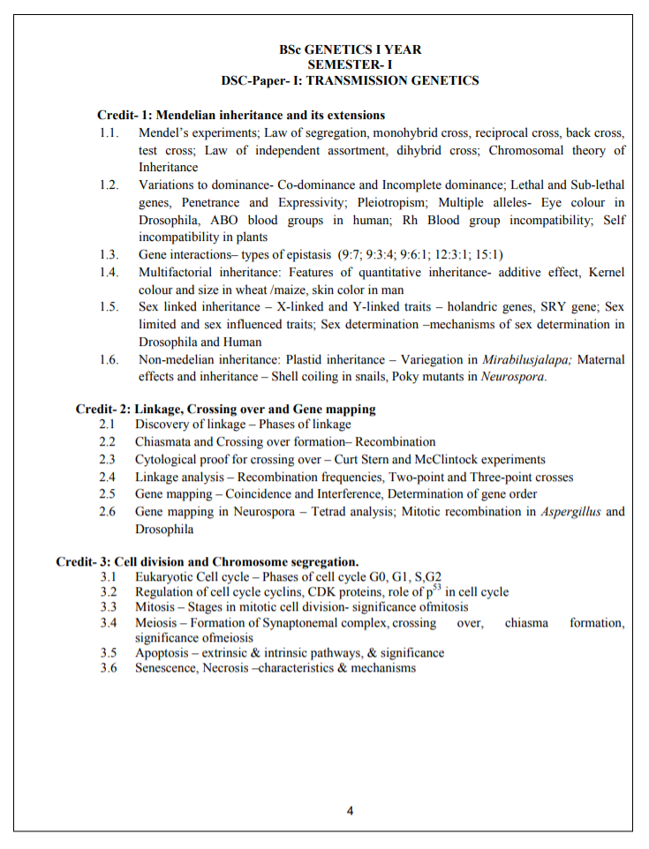

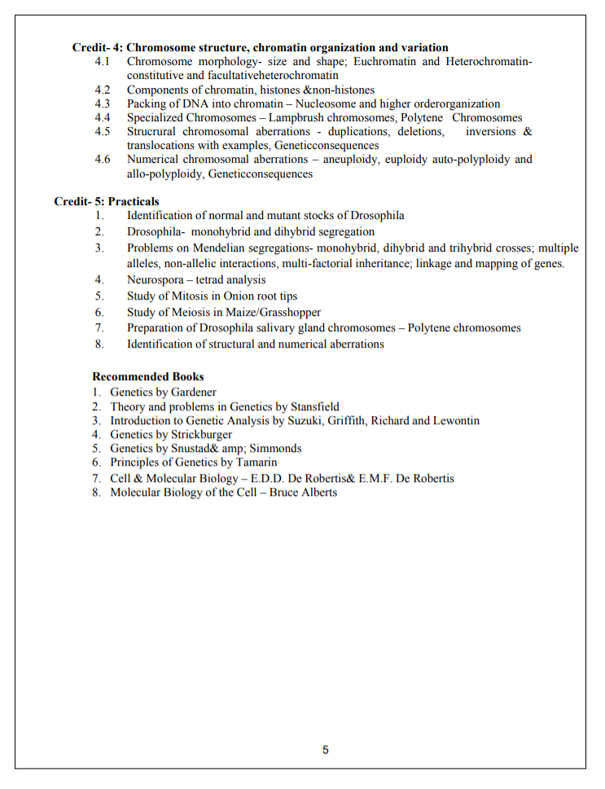

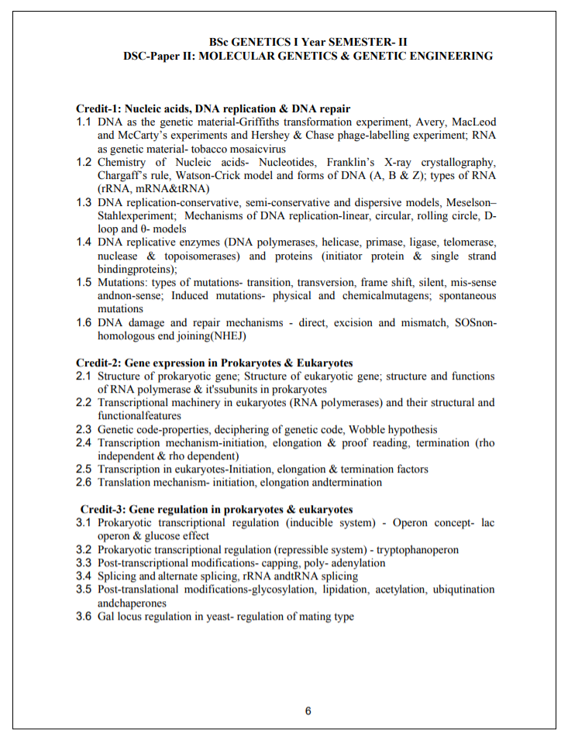

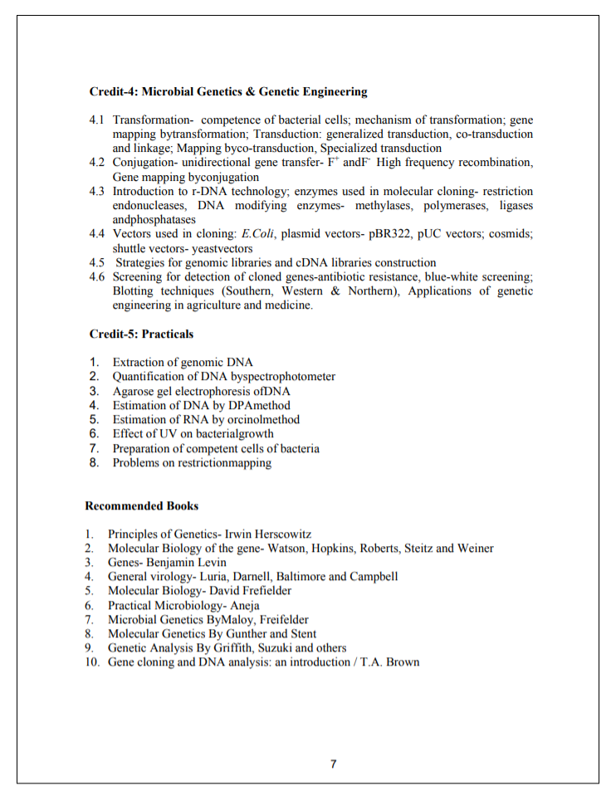
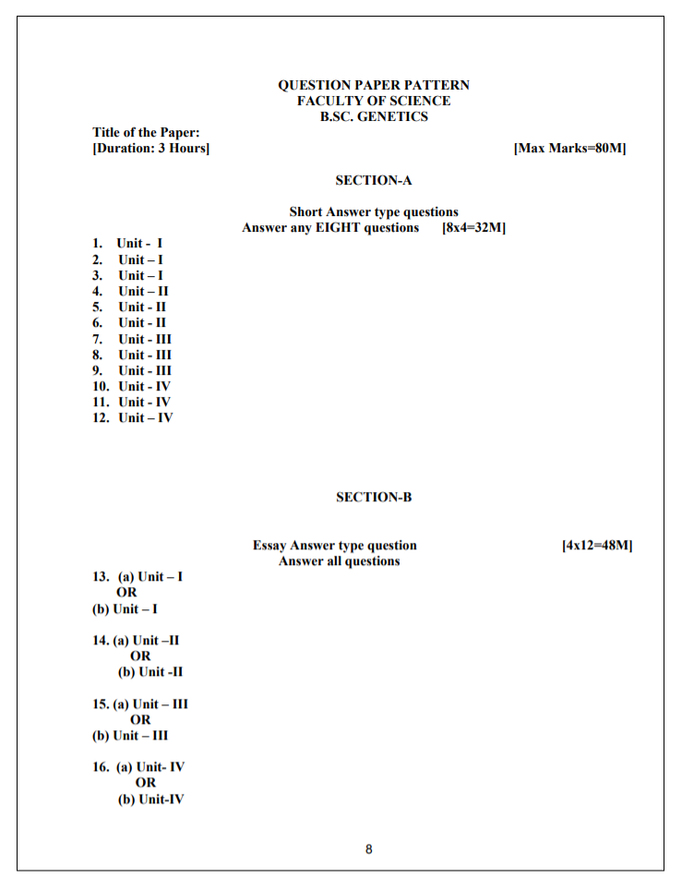

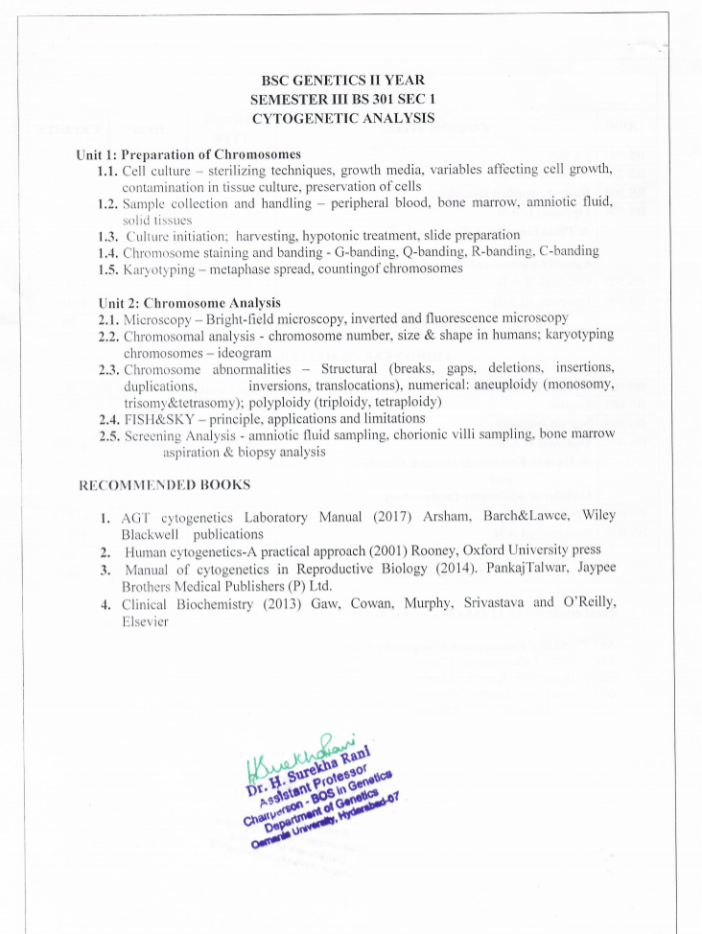

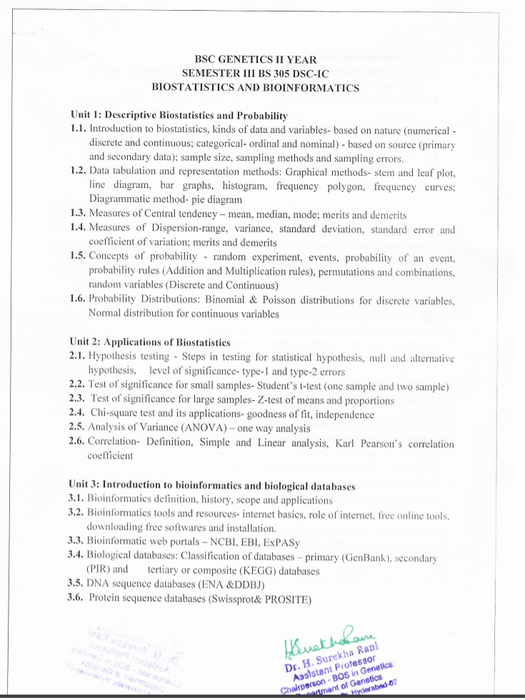

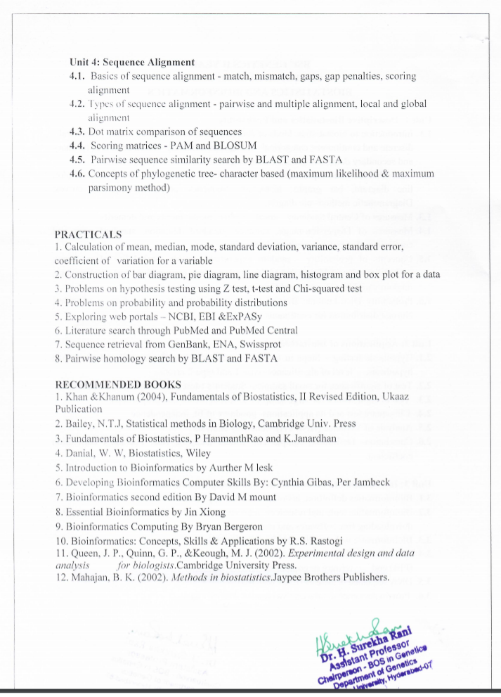

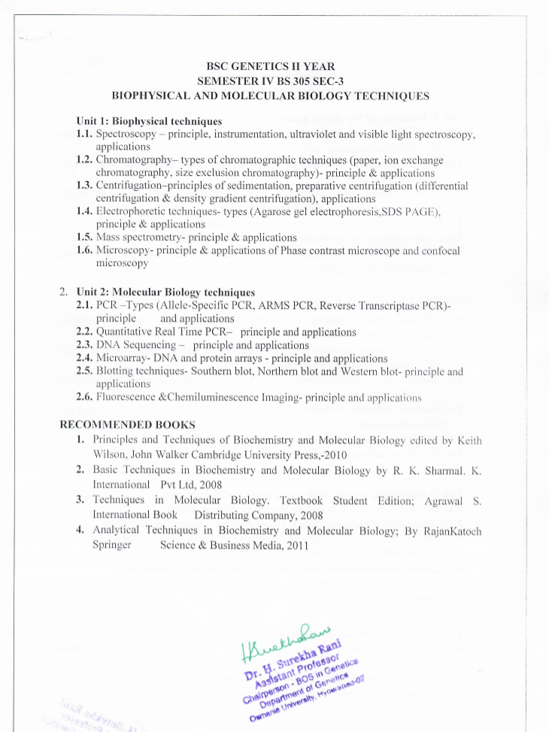

B.SC GENETICS II YEAR
SEMESTER – IV
DSD-1D-Paper-IV Industrial Microbiology and Biotechnology

Unit 1: Fundamentals of Microbiology and Industrially important microbes
1.1 Outlines of classification of microorganisms
1.2 Structure and general characteristics of bacteria and virus
1.3. Structure and general characteristics of micro-algae and fungi
1.4 Microbial screening of industrially important micro organisms – primary and secondary
1.5 Microbial strain improvement-Fungal strain improvement, Bacterial strain improvement
and Feed-back controls
1.6 Recombinant DNA in industrial microbiology

Unit 2: Culture and identification of microorganisms
2.1 Methods of sterilization – physical and chemical methods
2.2 Bacterial nutrition – nutritional types of bacteria, essential macro, micro nutrients and
growth factors
2.3 Bacterial growth curve- batch and continuous cultures, synchronous cultures
measurement of bacterial growth measurement of cell number and cell mass
2.4 Factors affecting bacterial growth
2.5 Culturing of anaerobic bacteria and viruses
2.6 Pure culture and its characteristics

Unit 3: Technology Behind Industrial Fermentation
2.1 Brief history of fermentation; Fermentation- general concepts
2.2 Fermentation design– Overview of Aerobic and Anaerobic fermentation process;
Submerged and solid state fermentation
2.2 Small scale, laboratory scale process and Large scale industrial production - Bioreactors
2.3 Process development and implementation-Design of Bioreactors
2.4 Upstream and downstream processing –solids and liquid handling; Factors affecting
fermentation process; Scaling up
2.6Downstream processing-Methods of extraction (flocculation, centrifugation and filtration);
Methods for disruption of cells, recovery of intracellular components (mechanical and non-
mechanical methods); Concentration and Purification of products ( evaporation, membrane
filtration, electro-dialysis, chromatography methods, drying and lyophilization)

Unit 4: Microbial Products Of Industrial Importance
3.1 Microbial enzymes – Amylases , Proteases, Pectinases
3.1 Citric acid, Acetic acid, Propionic acid, gluconic acid and itaconic acid
3.2 Enzymes in organic synthesis, proteolytic enzymes, hydrolytic enzymes, glucose
isomerise
3.3 Antibiotics - Penicillin, Streptomycin and Vaccines- BCG, Hepatitis vaccine
3.4 Alcohol, 2-3 butanediol and biofuels (biogas, biohydrogen, biodiesel)
3.5 Microbial insecticides, microbial flavours and fragrances.
3.6 Bioremediation of pesticides and xenobiotics

PRACTICALS
1. Preparation of microbiological media
( bacterial, algal & fungal)
2. Isolation of bacteria by streak, spread and pour plate methods
3. Isolation of bacteria from soil
4. Simple staining and differential staining (Gram’s staining)
5. Bacterial growth curve
6. Production of ethanol by yeast fermentation.
7. Production of citric acid
8. Testing water quality



