Report on Entrepreneurship and Career Mentorship Programme

An Entrepreneurship and career mentorship programme was organized by Human Capital Development Cell, UCW, koti in association with Ms. Shamantha Rani .M, founder of Sector Seven on 8th Dec, 21 at 12pm.
Ms. Shamantha spoke vastly about various careers, the skills needed to match each specific career and discussed how the students can upgrade themselves to match the said skills.
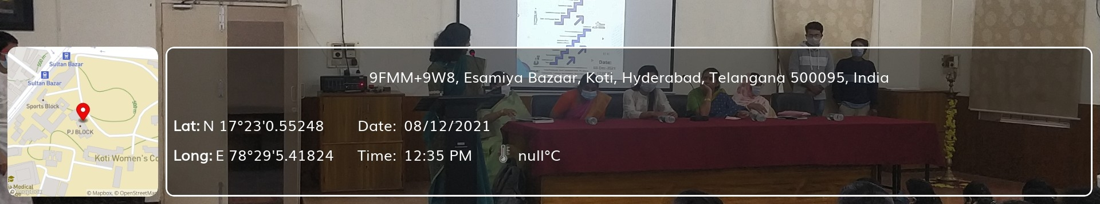
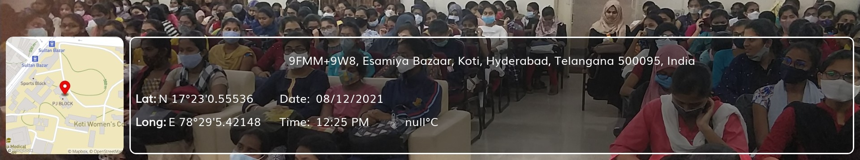
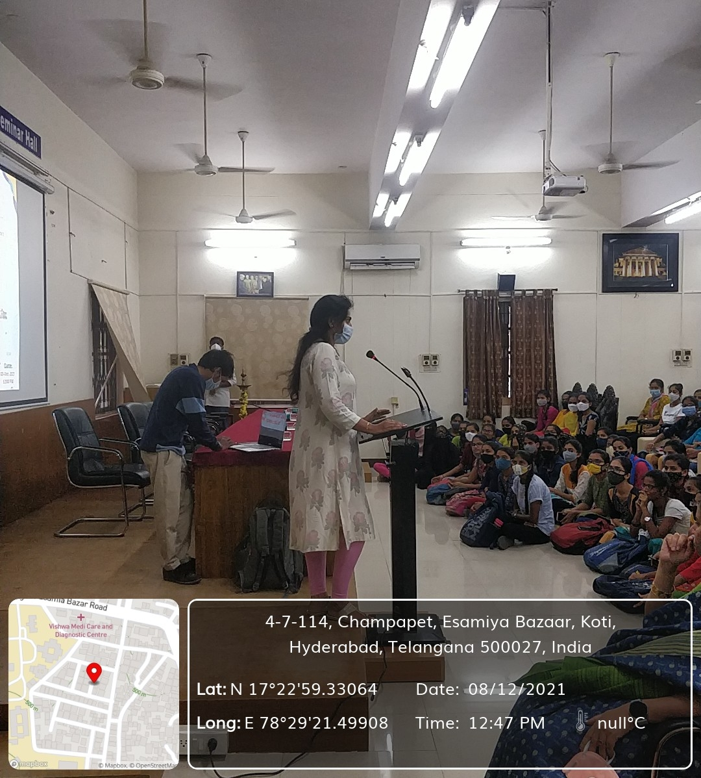
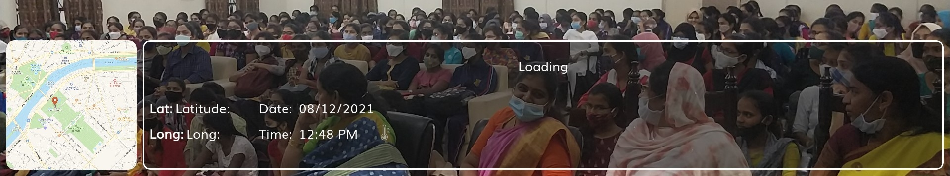
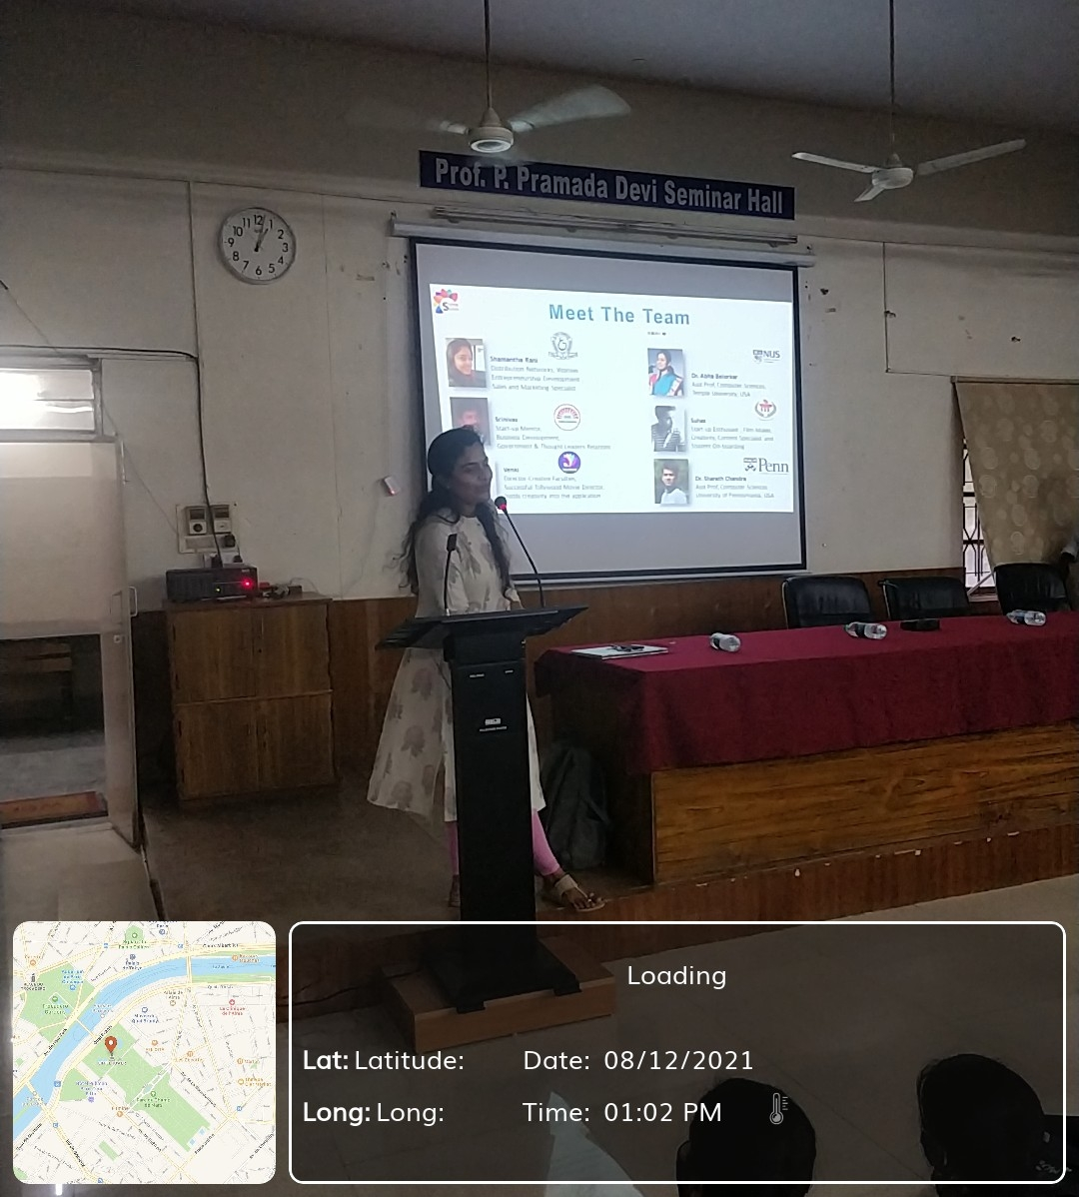
Ms. Shamantha then went on to introduce the incubation center run by her and gave a detailed description of how the center helps students prepare themselves to meet the rising demands of the global employment market.
The students shared their dreams and goals and sought advice on the pursuit of certain careers.
The session was attended by 200 undergraduate fifth semester students and was highly useful for giving a direction to their goals.

