REPORT on Pre-Placement Training, HCDC, 13thDec, 21 to 17 Dec, 21
The main objective of the Pre-Placement Training is to expose students to the Corporate Culture and explain them the processes followed there and to make them comfortable when they are exposed to it. To make them realise the importance of A-Z soft skills, Resume, communication, leadership and behaviour, and to help them understand the nuances of Group Discussions and interviews theoretically and practically.
Day 1: (13th Dec, 21)
Dr. G.LK. Durga began the session on the topic A-Z of soft skills in a unique way by using alphabets from A to Z. She explained every letter with real-life examples by using songs, jokes and stories. She gave a detailed overview of interpersonal skills, knowledge, leadership, how to be optimistic and how to achieve someone’s predetermined goal.
She also explained ethics, group work, negotiation skills and professionalism. She told students not to leave work to the last hour i.e., not to procrastinate and to prioritize a to-do list. She said that setting goals helps a person remain focused on being successful, stay away from distractions, and will help with motivation. The session was attended by 290 students of UG and P.G. It was a great experience for the students and they stayed bright and cheerful all through.

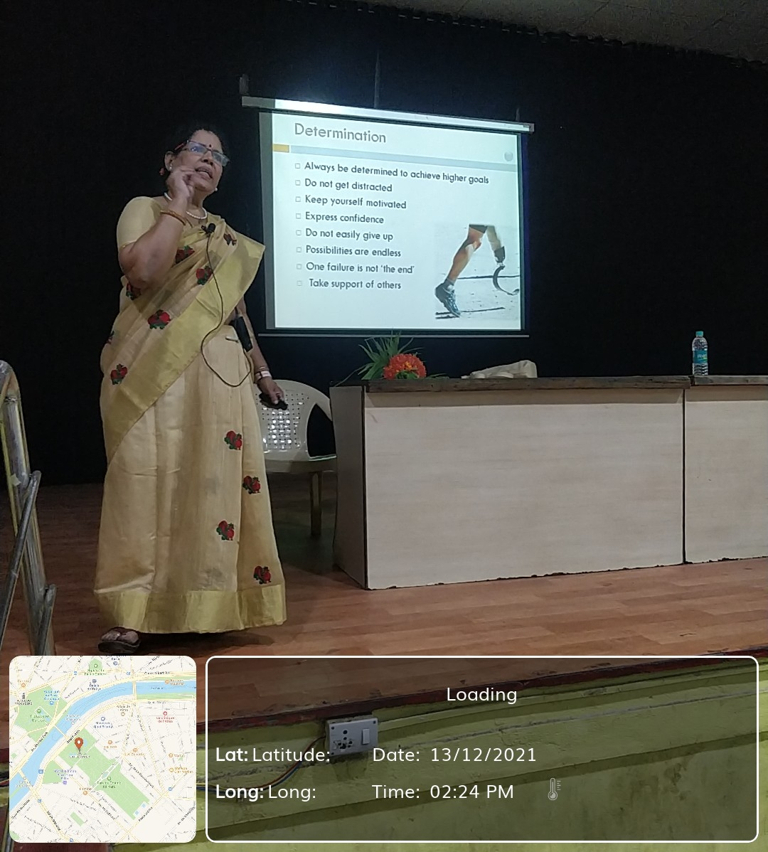

Day: 2 (14thDec, 21)
Ms. Mridulatha began the session on resume writing with a story using which she explained how to portray each individual's strengths and intelligence to portray the strengths. She then played a small game of offering a Cadbury to explain about grabbing an opportunity. She then went on to explain the difference between Resume, curriculum vitae, biodata and profile in a very simple way.
Then she went on to explain in detail how important it is for a resume to ‘scream out’ your potential, strengths and how we are an asset to the employer in 30 seconds or less. She explained each step clearly by involving student volunteers, calling them on to the dais and giving them hands-on training on all steps involved in highlighting their strengths in the resume such as writing a clear objective, educational qualifications in reverse chronological order, technical skills etc.
The session was attended by 290 U.G and P.G final year students of the College. It was greatly interactive where students played games to identify their positive qualities. The students went back equipped with knowledge on portraying themselves positively through their resume.

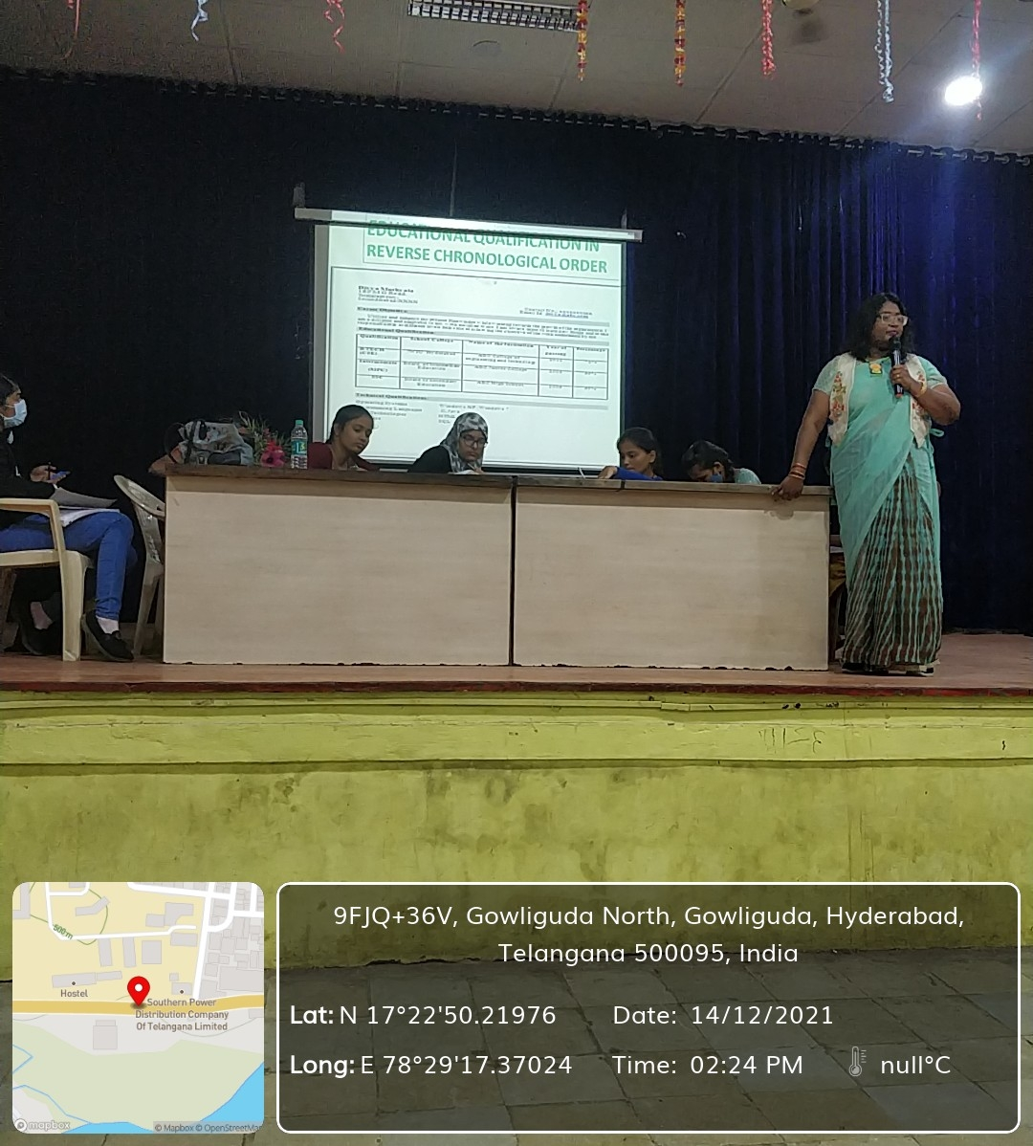

Day 3: (15thDec, 21)
The third session of the series was on Effective Communication by Ms. Ramya Raman. Right at the beginning, she made sure that the students were comfortable and at ease by conducting a small activity.
The activity introduced the students the strategies of communicating with different strata of people. It also helped explain the difference between communication and effective communication, and how good communicators are also good influencers. She taught the students how to present themselves convincingly to employers and to strategize communicating effectively, by giving everyday scenarios of communication as examples.
She went on to discuss the 5 Ws and 1 H of effective communication, and how these dictate the rules of effective communication.
She further discussed about the types of communication- oral, written and body language and the rules that govern each type of communication like the 3Vs and 7Cs and how to use these skills to make the opportunity count during an interview.
The session was attended by 290 students and was thoroughly enjoyed as the activities and examples were absolutely relatable to their level.
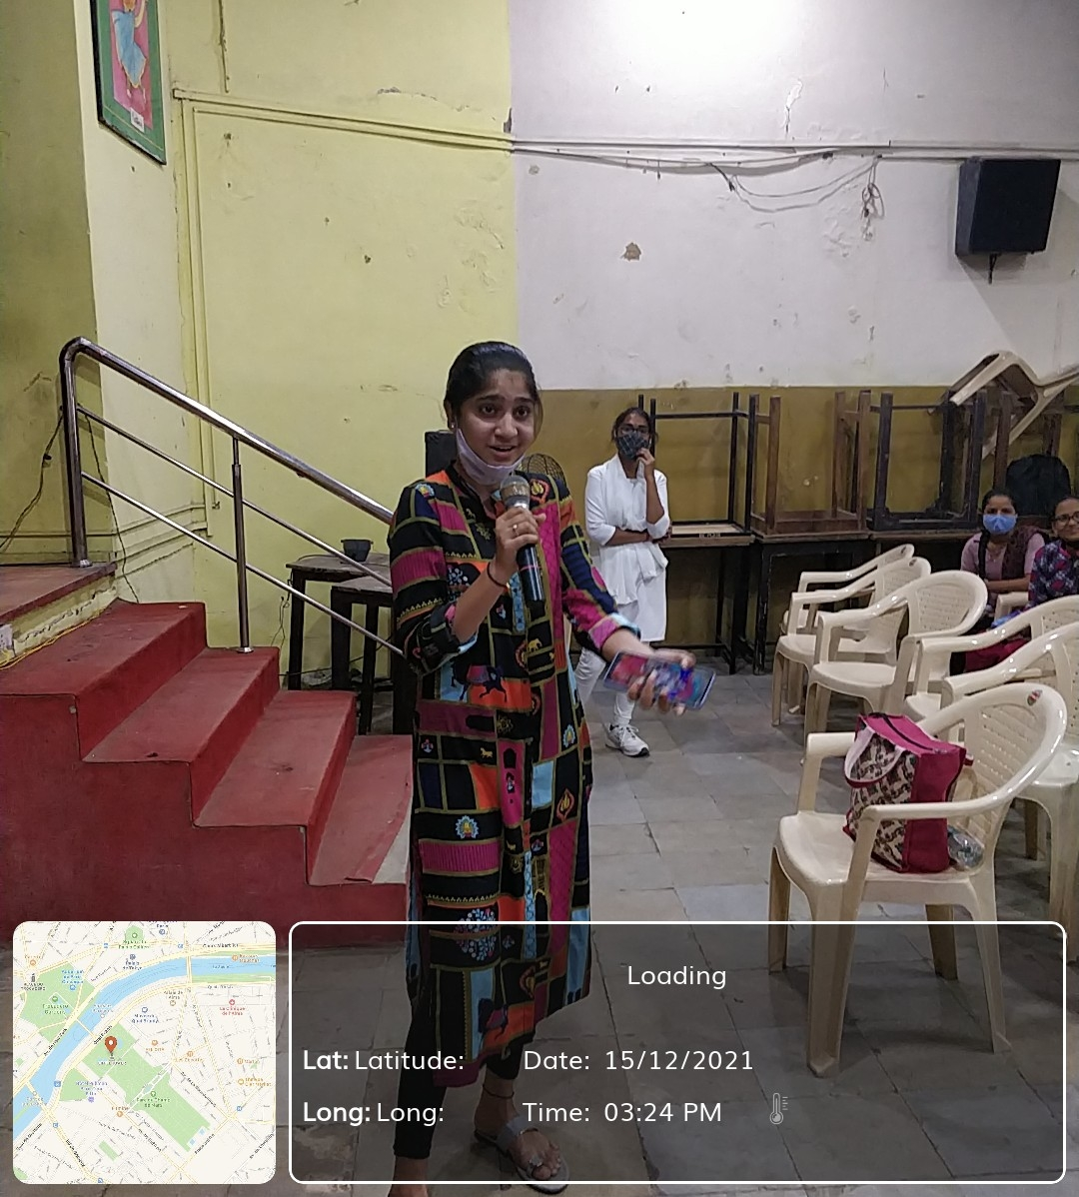

Day 4: (16thDec, 21)
Mr. Sudheer Sandra, the fourth speaker of the series, spoke on the topic ‘Leadership skills and team building’
He began the session by making the students sit up actively by quickly asking a few questions.
He opened up doors to skills which helps students fulfill their professional ambitions and live a rich life by introducing a concept called 6:8 that is 6 points and 8 thought provoking questions.
He conducted many activities to help the students understand and assess their key leadership qualities and realize the importance of self-motivation and self-drive to achieve dreams and goals. The session was attended by 290 students who enthusiastically participated in the brain stimulating games and thought provoking activities.
The session was extremely useful and interesting to all attendees, including teachers.

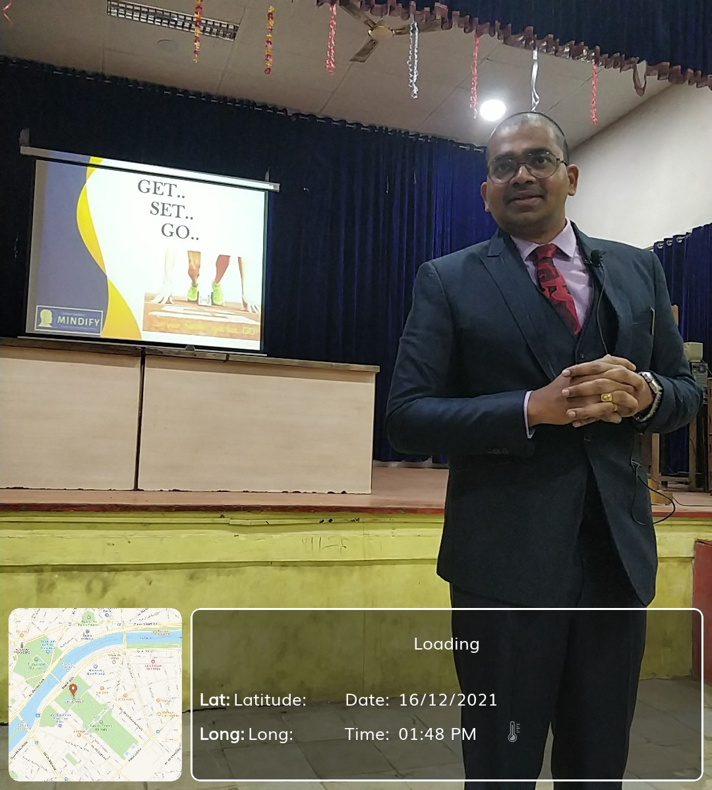
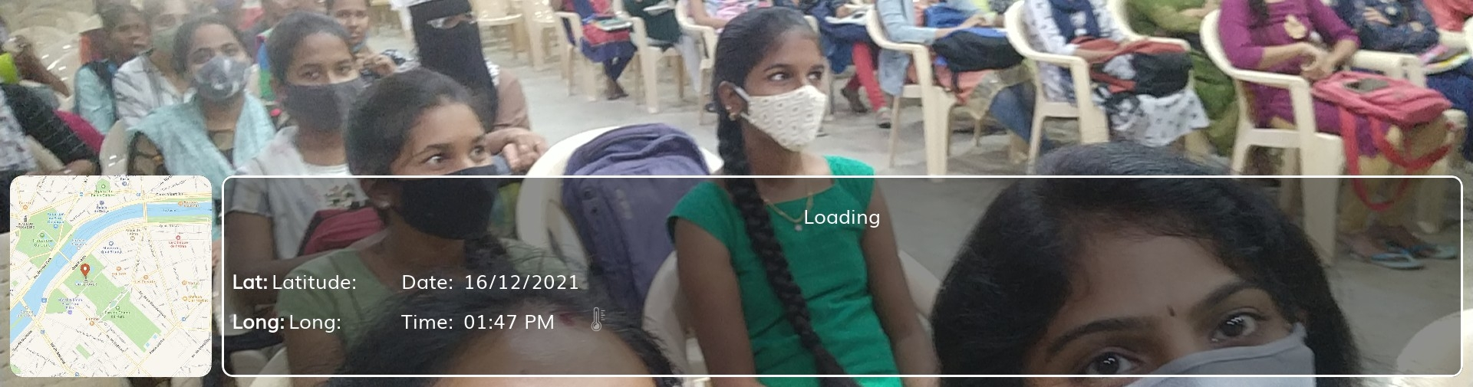

Day 5: (17th Dec, 21)
The last session of Pre-Placement training had Prof. A. Kamalakar, president, Shapiro Foundation, Melbourne, Australia as the speaker.
He launched straight into the topic ‘group discussion and interview skills'. He introduced the purpose, needs, advantages and rules of group discussion and also explained the criteria for evaluation during professional group discussions.
He clearly explained the qualities needed to impress during group discussion, starting with being a good listener and a team player.
He then went on to describe all the above attributes in the perspective of interview skills.
He then conducted mock group discussions and mock interviews to make sure the students got hands-on training on attaining knowledge essential to succeed in an interview and further their career pursuits.
The session was attended by 290 students and was extremely insightful.

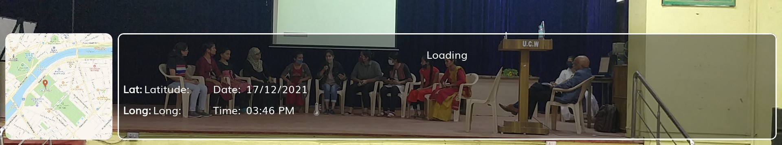

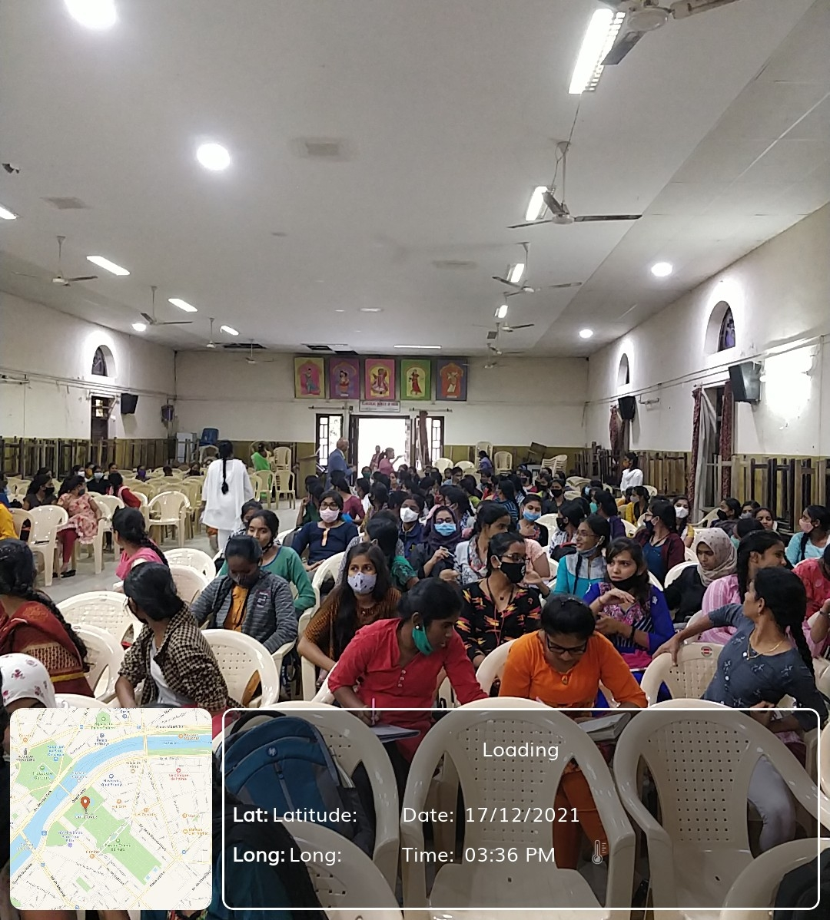

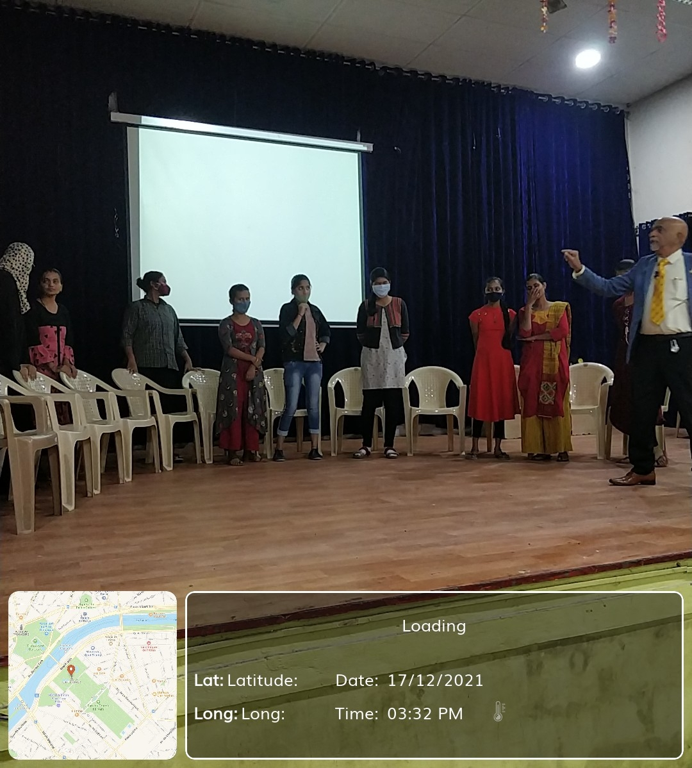

The pre-placement training program was attended by 292 students from UG and PG.The Pre-Placement Training Program was conducted successfully and majority of the participants took active part in theprogram.Overall, we had a wonderful experience by enlightening the students about the corporate world ethics. Not to forget, even we got to learn so much from them.

